WAG PRE-LEVELS BRONZE – FLOOR (1)
Statics | 1. Tuck | 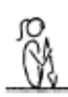 | - all positions must be performed with control and awareness  - maintain good body tension and alignment  - head neutral
 | 2. Pike | 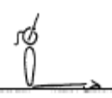 | - all positions must be performed with control and awareness  - maintain good body tension and alignment  - head neutral
 | 3. Closed Pike | 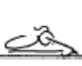 | - all positions must be performed with control and awareness  - maintain good body tension and alignment  - head neutral
 | 4. © Front Support | 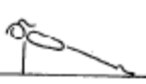 | - all positions must be performed with control and awareness  - maintain good body tension and alignment  - head neutral
 | 5. © Rear Support | 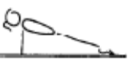 | - all positions must be performed with control and awareness  - maintain good body tension and alignment  - head neutral
 | 6. Squat | 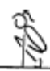 | - all positions must be performed with control and awareness  - maintain good body tension and alignment  - head neutral
 | 7. Layout |  | - all positions must be performed with control and awareness  - maintain good body tension and alignment  - head neutral
 | 8. Tuck Dish |  | - all positions must be performed with control and awareness  - maintain good body tension and alignment  - head neutral
 | 9. Arch | 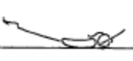 | - all positions must be performed with control and awareness  - maintain good body tension and alignment  - head neutral
 | 10. Shoulder stand/Candlestick | 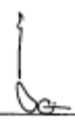 | - all positions must be performed with control and awareness  - maintain good body tension and alignment  - head neutral
 | 11. GF1.2 Floor Sequence – rear Layout position, tuck, egg roll to knees, angry cat, slide feet back to front support
Locomotion | 1. Log roll on floor
Fwd Roll  (for front salto) | 1. Candlestick to stand (assist) arms down
 | 2. © F1-1.2 From stand, squat roll back through a tuck position to a momentary shoulder stand, roll fwd through tuck to stand | 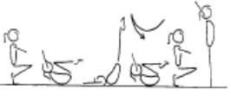 | - knees together, toes pointed  - ability to generated a smooth rocking action alone  - arms above head in shoulder stand position to  - enable a ‘chase’ action in the roll forward to stand  - hands on the front of the shins, below the  - kneecaps  - head tucked in, with chin on chest
 | 3. © Fwd roll to stand (can use hands to stand) | 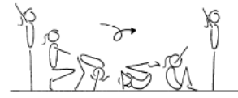 | - stretch before roll  - hands placed on the floor near the feet  - feet together  - tuck head under (look at belly button)  - roll quickly over the head  - roll should be in a neat, tight tuck, knees together and toes pointed  - roll up to stand  - stretch after roll

WAG PRE-LEVELS BRONZE – FLOOR (2)
Handstand (for walkover, handspring and flic flac) | 1. Angry Cat/Happy Cat position – hold 10 secs
 | 2. GF1.3 Marching on Hands
 | 3. © F1-2.1 Front support with feet on a raised surface – hold 10 secs | 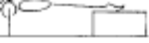 | - maintain body tension and alignment  - head neutral
 | 4. F1-2.4 From a tuck position, jump to tuck handstand, rebound off the floor to tuck handstand x 10, non stop | 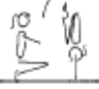 | - arms straight  - chest rounded, extended through the shoulders  - good closure during tuck, pike and straddle  - hips open  - gluteal muscles squeezed  - head neutral  - maintain good body tension and alignment
 | 5. GF3.6 Walking up the wall | 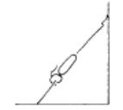 | - arms straight  - chest rounded, extended through the shoulders  - hips open  - gluteal muscles squeezed  - head neutral  - maintain good body tension and alignment
Cartwheel / Roundoff | 1. F1-4.1 With hands on a raised surface, have the gymnast climb from one side to the other
 | 2. F1-4.2 with hands on a raised surface, jump from one side to the other | 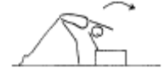 | - hands parallel, straight arms  - head neutral  - feet close to hands  - small straddle during the jump
 | 3. © GF4.4 Bunny hop turn out
 | 4. Show star position standing with arms stretched up – feet apart – completely straight body
 | 5. Show star position lying down with arms stretched up – feet apart – completely straight body
Leaps/Jumps | © 1. Chasse Gallops R – 1 length, L – 1 length
Turns | 1. © Learn side passé and fwd passé position – holding onto something stable
FWO, BWO & Tic Toc | 1. Bridge rocking on back lying over a cylinder – with assistance | 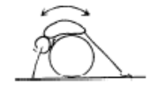 | - this drill allows the gymnast to experience the  - correct movement pattern, the gymnast can rock  - back and forth placing weight on their hands and  - then feet
 | 2. Seal – feet towards head

MAG PRE-LEVELS BRONZE – FLOOR (1)
Statics | 1. Tuck |  | - all positions must be performed with control and awareness  - maintain good body tension and alignment  - head neutral
 | 2. Pike |  | - all positions must be performed with control and awareness  - maintain good body tension and alignment  - head neutral
 | 3. Closed Pike |  | - all positions must be performed with control and awareness  - maintain good body tension and alignment  - head neutral
 | 4. © Front Support |  | - all positions must be performed with control and awareness  - maintain good body tension and alignment  - head neutral
 | 5. © Rear Support |  | - all positions must be performed with control and awareness  - maintain good body tension and alignment  - head neutral
 | 6. Squat |  | - all positions must be performed with control and awareness  - maintain good body tension and alignment  - head neutral
 | 7. Layout |  | - all positions must be performed with control and awareness  - maintain good body tension and alignment  - head neutral
 | 8. Tuck Dish |  | - all positions must be performed with control and awareness  - maintain good body tension and alignment  - head neutral
 | 9. Arch |  | - all positions must be performed with control and awareness  - maintain good body tension and alignment  - head neutral
 | 10. Shoulder stand/Candlestick |  | - all positions must be performed with control and awareness  - maintain good body tension and alignment  - head neutral
 | 11. GF1.2 Floor Sequence – rear Layout position, tuck, egg roll to knees, angry cat, slide feet back to front support
Locomotion | 1. Log roll on floor
Fwd Roll  (for front salto) | 1. Candlestick to stand (assist) arms down
 | 2. © F1-1.2 From stand, squat roll back through a tuck position to a momentary shoulder stand, roll fwd through tuck to stand |  | - knees together, toes pointed  - ability to generated a smooth rocking action alone  - arms above head in shoulder stand position to  - enable a ‘chase’ action in the roll forward to stand  - hands on the front of the shins, below the  - kneecaps  - head tucked in, with chin on chest
 | 3. © Fwd roll to stand (can use hands to stand) |  | - stretch before roll  - hands placed on the floor near the feet  - feet together  - tuck head under (look at belly button)  - roll quickly over the head  - roll should be in a neat, tight tuck, knees together and toes pointed  - roll up to stand  - stretch after roll

MAG PRE-LEVELS BRONZE – FLOOR (2)
Handstand (for walkover, handspring and flic flac) | 1. Angry Cat/Happy Cat position – hold 10 secs
 | 2. GF1.3 Marching on Hands
 | 3. © F1-2.1 Front support with feet on a raised surface – hold 10 secs |  | - maintain body tension and alignment  - head neutral
 | 4. F1-2.4 From a tuck position, jump to tuck handstand, rebound off the floor to tuck handstand x 10, non stop |  | - arms straight  - chest rounded, extended through the shoulders  - good closure during tuck, pike and straddle  - hips open  - gluteal muscles squeezed  - head neutral  - maintain good body tension and alignment
 | 5. GF3.6 Walking up the wall |  | - arms straight  - chest rounded, extended through the shoulders  - hips open  - gluteal muscles squeezed  - head neutral  - maintain good body tension and alignment
Cartwheel / Roundoff | 1. F1-4.1 With hands on a raised surface, have the gymnast climb from one side to the other
 | 2. F1-4.2 with hands on a raised surface, jump from one side to the other |  | - hands parallel, straight arms  - head neutral  - feet close to hands  - small straddle during the jump
 | 3. © GF4.4 Bunny hop turn out
 | 4. Show star position standing with arms stretched up – feet apart – completely straight body
 | 5. Show star position lying down with arms stretched up – feet apart – completely straight body
FWO, BWO & Tic Toc | 1. Bridge rocking on back lying over a cylinder – with assistance |  | - this drill allows the gymnast to experience the  - correct movement pattern, the gymnast can rock  - back and forth placing weight on their hands and  - then feet
 | 2. Seal – feet towards head

PRE-LEVELS BRONZE – BARS (1)
Hanging & Grip Strength | 1. © Shimmy along the bar (tight legs)
 | 2. Hanging ½ turns x 3
Tuck Swings /Glides | 1. © Show glide position lying on a box
 | 2. Swing – drop bean bag in hoop
Front Support /Casts | 1. © B1-1.1 Front support on floor bar with feet raised on box
 | 2. Jump to front support (good technique) | 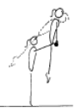 | - straight arms throughout the jump to front support cast to land phase  - chest rounded on the bar  - good use of swing during the cast phase
Fwd Roll Dismount | 1. © B1-2.1 Tuck leg lifts – on wedge x 2 | 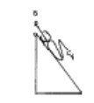 | - maintain good body tension and alignment  - knees to chest
 | 2. Show tuck hang hold – 5 secs
 | 3. Front support lean fwd on bars
 | 4. Basket hang
Pullover | 1. © Holding toes to the bar spotted – 5 secs
 | 2. Chin up hold on own – 3 secs
 | 3. Swing on rings in tuck position 2 x fwd and bwd (with box under so gymnast remains in tuck position)

PRE-LEVELS BRONZE – BEAM (1)
Front support Mount | 1. © M1-1.3 Stride sit/support on the beam, swing legs | 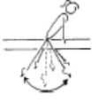 | - maintain good body tension and alignment  - arms straight  - shoulders will be slightly in front on hands during the back swing  - keep torso clear of the Beam
 | 2. Jump to front support | 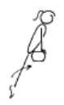 | - straight arms in front support  - legs straight during the first phase
Kneeling Scale | 1. M1-3.1 Crawling on mid beam with crash mat under | 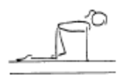 | - arms straight  - good rhythm  - head up, eyes down
 | 2. Bear walks along mid beam with crash mat under | 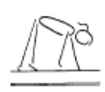 | - arms straight  - good rhythm  - head up, eyes down
Attitude Steps | 1.M1-5.1 Stand on the floor with free leg on low beam, swap legs | 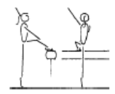 | - emphasise the turn out and toe point  - head up, eyes down  - good posture  - opposite arm to leg
Releve/Turns | 1. © M1-2.1 Releve on the beam – held for 3 sec | 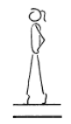 | - one foot slightly in front of the other, both legs slightly turned out  - legs squeezed together  - legs straight, knees locked  - heels pushed forward into a high arch shape  - ankles should be stable  - equal weight on both feet  - maintain good body tension and alignment
 | 2. M1-4.1 Play on the floor with spinning or swiveling on toes
Locomotion | 1. Step points to end of beam
 | 2. © M2-3 Grapevine along bench/low beam | 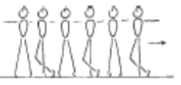 | - good rhythm  - confidence  - good body alignment and control  - εextended toes, ankles, knees and hips
 | 3. M2-3 Jumping along low beam/bench – swinging arms | 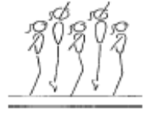 | - good rhythm  - confidence  - good body alignment and control  - εextended toes, ankles, knees and hips
Jumps /Leaps | 1. Standing on low beam – flat feet, swing arms bwd with bent knees then fwd to ears as legs straighten – stay on flat feet
 | 2. © M1-7.1 Perform a releve on low beam with a bean bag on head – on own |  | - one foot slightly in front of the other, both legs slightly turned out  - legs squeezed together  - legs straight, knees locked  - heels pushed forward into a high arch shape  - ankles should be stable  - equal weight on both feet  - maintain good body tension and alignment
Stride Leap | 1. Step kicks bwd on low beam or middle beam with crash mat under
Handstand | 1. © M3-4.1 Front support with hands on a low beam and feet on a box – performed on the side | 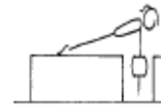 | - shoulders and hips square  - hips under, chest in  - head neutral
Landing Drills | 1. Can you move me/ shake me in landing position | 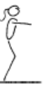 | - on landing the hips must be under  - on landing the shoulders, hips and ankles should all be in a vertical line
 | 2. Clap – don’t jump off beam until coach claps
Straight Jump Dismount | 1. © St jump off mid beam to HOLD land for 3 secs | 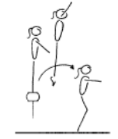 | - stretched arms overhead  - legs straight in the air  - vertical take off  - on landing the hips must be under  - on landing the shoulders, hips and ankles should all be in a vertical line
PRE-LEVELS BRONZE – VAULT (1)
Landing | 1. © V1-2.1 Landings off a box – straight and tuck
Bounce /Spring | 1. V1-1.1 Assisted bounces on the floor – coach holds the gymnast by the hands in front
 | 2. V1-5 Springing circuit – 5 bean bags/teddies | 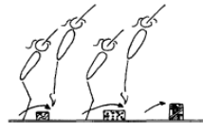 | - maintain good body tension and alignment  - continuous bouncing, no pauses or stops  - easy clearance of the objects
 | 3. GF3.7 5 x hopping steps on each leg
 | 4. © Jumping bwds
 | 5. Jumping Sideways
Running | 1. Running | 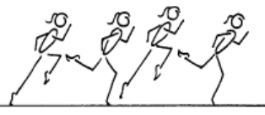 | - good body alignment  - fast action  - arms bent at 90', moving beside body  - legs moving within the body line  - body straight with slight forward lean  - maximum forward speed is essential  - head remains neutral and still
 | 2. © V2-3.1 Stand swing arms bent 90’ | 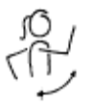 | - bent arms - arms do not drop, or straighten out  - alignment - arms do not swing across body or out to the side  - arms have 90’ bend, lift to eye level and swing back to body line
Hurdles | 1. V2-4.1 Step to hurdle on the floor – arms down when feet land
Straight Jump Vault | 1. © V1-3.1 Perform bounce from the board to the floor up to a low shape (or 2nd board) | 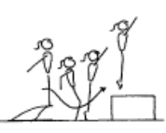 | - underarm action  - fast explosive bounce  - arms stop at 45’  - maintain good body tension and alignment
Dive Roll / Front Salto | 1. © Run along bench – mini-tramp, tuck jump to land on 30cm crash mat

